

ENGINEERING PROGRAM

INT 102 FINAL REPORT

TITLE OF THE INTERNSHIP

BY
Student first name and last name

ACADEMIC SUPERVISOR
first name and last name

INSTITUTION SUPERVISOR
first name and last name
Institution name

(Read well the report related section in the MedTech Internship Guide + the next 2 pages before writing this report)

Tunis, 2025-2026

After well reading the content of this page, delete it

In order to increase the chances for your internship to be accepted please respect these points mentioned in previously sent mails :

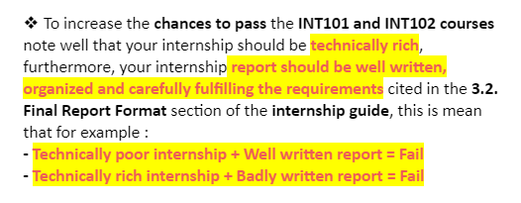
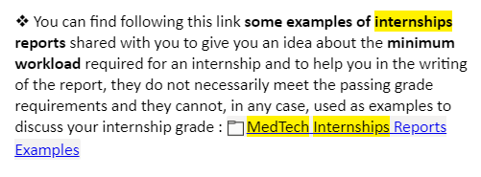
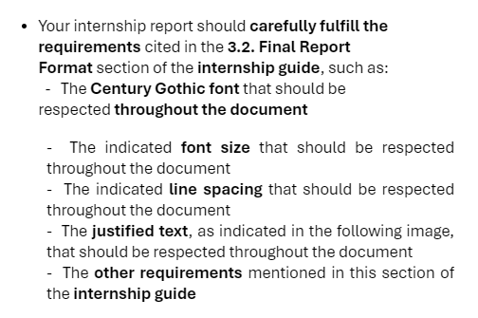
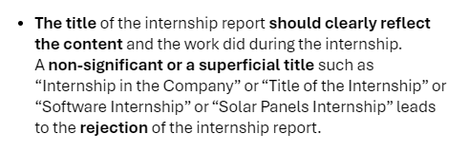
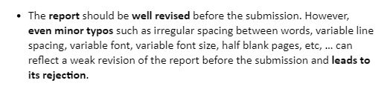
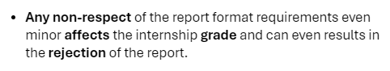

You should carefully respect these points when writing your internship report :
- the overall appearance and language of the report.
- the report structure & the cohesion between the different parts.
- the accuracy in describing the internship context.
- the theoretical framing of the internship.
- the methodology & the highlighting of the technical richness of the internship.
- the description of results and the depth of conclusions.

Approval

APPROVED BY

ACADEMIC SUPERVISOR

Name Signature Date

COMPANY SUPERVISOR

Name Signature Date

ACADEMIC EVALUATOR

Name Signature Date

Declaration

I certify that I am the author of this project and that any assistance I received in its preparation is fully acknowledged and disclosed in this project. I have also cited any source from which I used data, ideas, or words, either quoted or paraphrased. Further, this report meets all the rules of quotation and referencing in use at MedTech, as well as adheres to the fraud policies listed in the MedTech honor code.

No portion of the work referred to in this study has been submitted in support of an application for another degree or qualification to this or any other university or institution of learning.

Student Name Signature Date

Work Term Release

I hereby state and verify by my signature that I have reviewed this report. I hereby affirm that the report contains

no confidential data/information, and I authorize it to be released.

confidential data/information, and I do not authorize it to be released.

COMPANY SUPERVISOR

Name Signature Date

Internship Agreement and Certificate Submission Receipt
(To be placed here)
Abstract

Keywords:

Acknowledgements

Table of Contents

Approval ii
Declaration iii
Work Term Release iv
Abstract v
Acknowledgements vi
List of Tables 8
List of Figures 9
List of Equations 10
1. EXECUTIVE SUMMARY 11
2. INTRODUCTION 12
3. COMPANY CONTEXT 13
3.1. Description of the company 13
3.2. Mission and Objectives 13
3.3. Industry structure 13
3.4. Market Structure 13
4. INTERNSHIP DESCRIPTION 14
4.1. Internship Context 14
4.2. General and specific objectives of the internship 14
4.3. Challenges and Obstacles 14
4.4. Assigned Tasks and Responsibilities 14
5. LITERATURE REVIEW 15
6. METHODOLOGY 16
7. RESULTS AND FINDINGS 17
8. RECOMMENDATIONS 18
9. CONCLUSIONS 19
REFERENCES 20
APPENDIX 21

List of Tables

List of Figures

List of Equations

EXECUTIVE SUMMARY
The executive summary is concise and outlines key issues and recommendations that you believe management should follow to address the selected topic. Consequently, you will be unable to write the executive summary until you have completed the entire report.

INTRODUCTION
The purpose of an introduction is to formulate the purpose statements and research or investigation questions. It contextualizes your work and enables the reader to understand and appreciate your objectives.

COMPANY CONTEXT

Description of the company
Describe where your internship was carried out (company, department, position(s) held, etc.). You might also describe such things as how your organization was structured, the work environment, etc.

Mission and Objectives

Industry structure

Market Structure

INTERNSHIP DESCRIPTION
Describe your internship topic here.

Internship Context

General and specific objectives of the internship

Challenges and Obstacles
Describe any challenge/obstacles you faced during your project, and how you coped with them.

Assigned Tasks and Responsibilities
Summarize your project goals, activities, accomplishments, specific Tasks/assignments that you did alone or with others, and staff meetings that you take part in and your specific role/contribution in each meeting.
In addition, describe the key learning’s you took away from your project. What company initiatives you observed, etc.)?

LITERATURE REVIEW
Relate your project topic to current literature or a theoretical framework.

METHODOLOGY
Choose strategies and methods in concordance with research- or investigation questions, then discuss, motivate and explain these choices: what did you use, a qualitative or quantitative research methods? Did you administer a questionnaire or interview people? Any field research conducted? How did you collect data? Did you utilize other libraries or archives?

RESULTS AND FINDINGS

RECOMMENDATIONS
This section should clearly and concisely state the issue facing the organization as substantiated by your analysis of the situation. Fundamental to determining the key issue is a statement of consequence regarding the potential impact for the firm if nothing is done (Explain the consequences if the key issues are not addressed by management).
This should directly relate to the current situation of the company and the results/findings of your study.

CONCLUSIONS
The conclusion brings everything together. A stimulating and informative conclusion leaves the reader informed and well-satisfied.

REFERENCES
Generally, only references cited in the text are included in the references list; however, an occasional exception can be found to this rule. For example, supervisors may require evidence that students are familiar with a broader spectrum of literature than that immediately relevant to their study/report. In such instances, the reference list is called a bibliography.

All material must be referenced using the IEEE style as indicated in the MedTech Internship guide. All sources must be acknowledged in your reports each time you use a finding from someone's work. For more details: https://ieeeauthorcenter.ieee.org/wp-content/uploads/IEEE-Reference-Guide.pdf

APPENDIX
The following materials are appropriate for an appendix: company specific data/information, market data, material that is additional to the information supplied in the main write up.

